Unit 10 Study Guide
Ecology/Biotic/Abiotic Assessment

- Terms to know:
- Population  - Population density  - Population dispersion (spacing)  - Limiting factors  - Density independent factors  - Density dependent factors | - Community  - Ecosystem  - Energy pyramid  - Heterotroph  - Autotroph  - Nitrogen Cycle  - Predation

- Short Answers:
14. What is symbiosis?
15. Describe three types of symbiotic relationships and provide an example of each.
16. What is the difference between abiotic factors in an ecosystem and biotic factors in an ecosystem? Provide two examples of each.
17. Compare and contrast a food web and a food chain. Provide an illustration for each.
18. If a cage has an area of 100 square feet and contains 50 dogs, what is the population density of the dog population?
19. Name one example of a density dependent limiting factor.
20. Name one example of a density independent limiting factor.
21. Describe 3 ways in which populations are spread out in an ecosystem (spacing).
22. Why do members of a clumped population form small groups within an ecosystem?
23. What are the different types of feeding relationships. Provide one example for each.
-----------------Examine the following evolution tree-------------------------

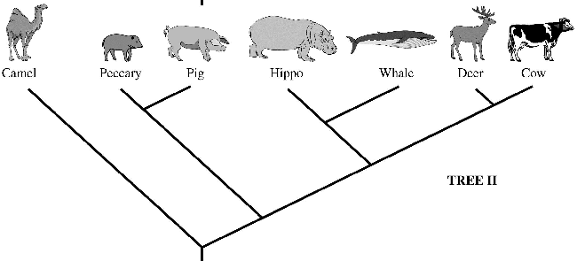

24. Which animal is the pig mostly related to? Explain why…
25. Which animal is the deer mostly related to? Explain why…

